Account Name : CORBETT TOURISM CONSULTING AND MARKETING
Account Number : COR009R

 | 
CORBETT TOURISM CONSULTING AND MARKETING - COR009R

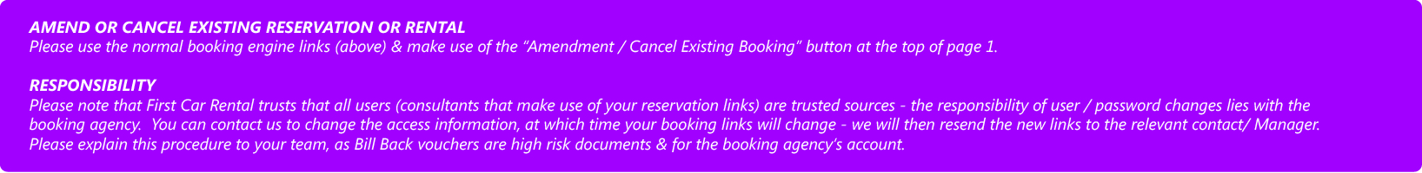

Sales Contact Name Signature

Date Place Name Signature

